
W3 PRACTICE

Express Basics + POST + Middleware

At the end of this practice, you can
  - Create and run a express.js HTTP server
  - Implement route handling using express.js
  - Parse form data from POST requests with middleware.
  - Apply middleware concept to logging

 Get ready before this practice!
  - Read the following documents to understand the nature of Express.js: https://expressjs.com/
  - Read the following documents to know more about Express.js’s built-in middleware’s: https://expressjs.com/en/resources/middleware.html

  - Read the following documents to understand MDN: HTTP POST: https://developer.mozilla.org/en-US/docs/Web/HTTP/Reference/Methods/POST
  - Read the following documents to array filter: https://developer.mozilla.org/en-US/docs/Web/JavaScript/Reference/Global_Objects/Array/filter

 How to submit this practice?
    - Once finished, push your code to GITHUB
    - Join the URL of your GITHUB repository on LMS



Ex01: – Refactoring

Goals

- Take advantage of Express.js framework’s flexibility and minimalism
- Refactor code from node.js’s built-in HTTP Module

 Refactor the source code of EXERCISE 2 & 3 in Week 2 to Express.js

Q1 – What challenges did you face when using the native http module that Express.js helped you solve?
- Using the native http module required manually inspecting req.url and req.method for every incoming request.
Without a routing system, every new endpoint meant adding another if/else or switch branch. Parsing query strings required the built-in url module, and reading POST bodies meant accumulating chunks with req.on("data") listeners. Express solved all of these automatically:
- Automatic route matching via app.get(), app.post(), etc.
- Built-in req.params and req.query for path and query string parsing.
- express.json() middleware that parses JSON bodies without manual chunk accumulation.
- A clean, chainable middleware system instead of a single monolithic request handler.
Q2 – How does Express simplify route handling compared to the native HTTP server?
- Express simplify route handling compared to the native HTTP server such as :
With the native http module, route handling is entirely manual:
EX.
// Native http — every route is a manual if/else
if (req.method === "GET" && req.url === "/about") { ... }
else if (req.method === "POST" && req.url === "/submit") { ... }

- Express replaces this with a declarative routing API:
Ex.
// Express — clean, readable, and automatically matched
app.get("/about", (req, res) => res.send("About Page"));
app.post("/submit", (req, res) => res.json(req.body));

Q3 – What does middleware mean in Express, and how would you replicate similar behavior using the native module?

- In Express, middleware is any function with the signature (req, res, next). It sits between the incoming request and the final route handler, allowing code to be run, req/res to be modified, or the chain to be short-circuited (e.g., for auth failures) before the request reaches its destination.
// Express middleware example
const logger = (req, res, next) => {
console.log(`${req.method} ${req.url}`);
next(); // pass control to the next middleware/route
};
app.use(logger); // apply globally
To replicate similar behavior in the native http module, you would need to build a manual pipeline: create an array of handler functions, iterate through them, and call each one in sequence — essentially rebuilding what Express provides out of the box.

Ex02: The Express Foundation
Goal: Initialize an Express application and start the server.
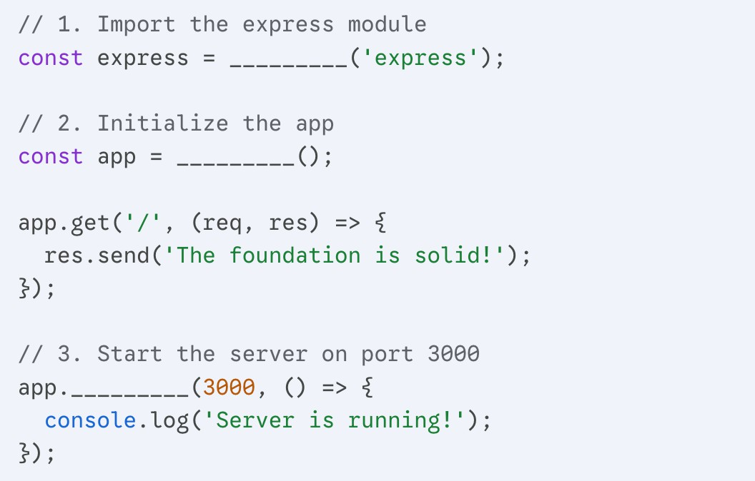

- Answer:
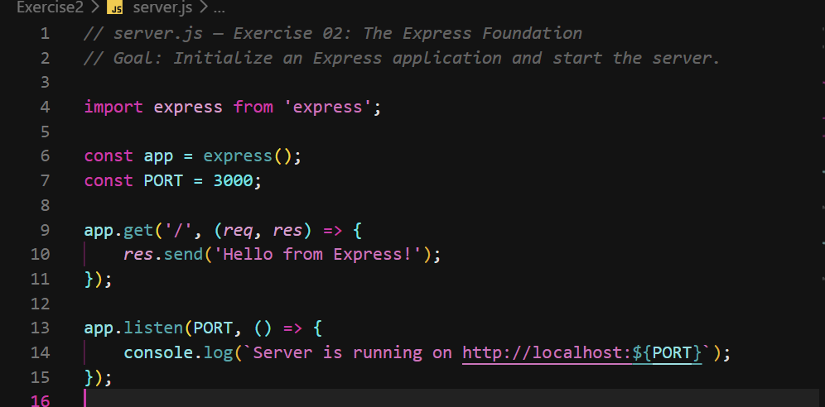

Ex03: The "ID" Hunter (req.params)
Goal: Practice capturing dynamic segments of a URL path.
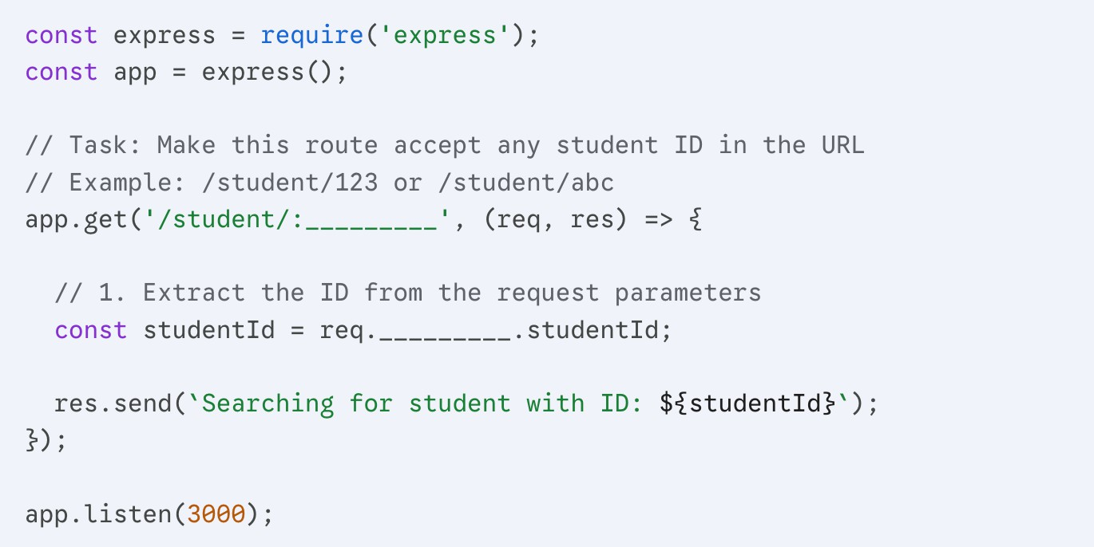
- Answer:

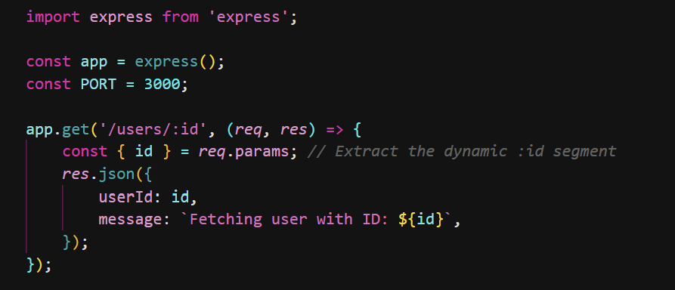

Ex04: The Filter Specialist (req.query)
Goal: Use query strings (the part after the ?) to "filter" a response.
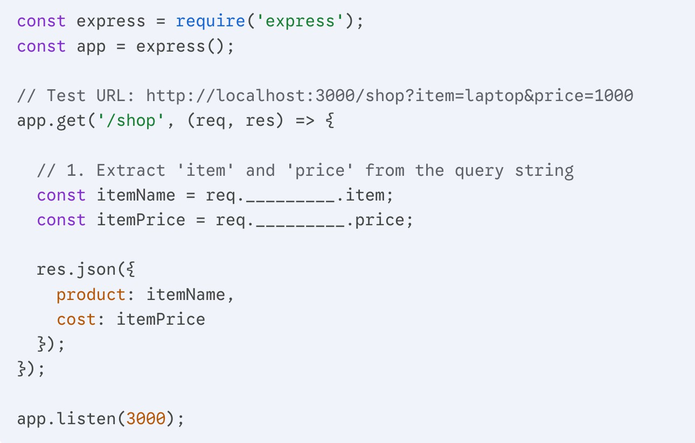

Answer =>
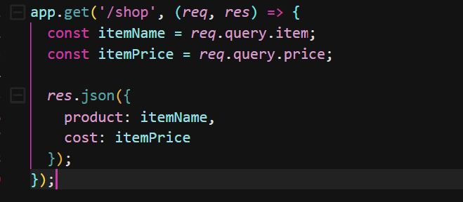

Ex05: The "Next" Step (Middleware)
Goal: Understand how middleware processes a request before it reaches the final route.
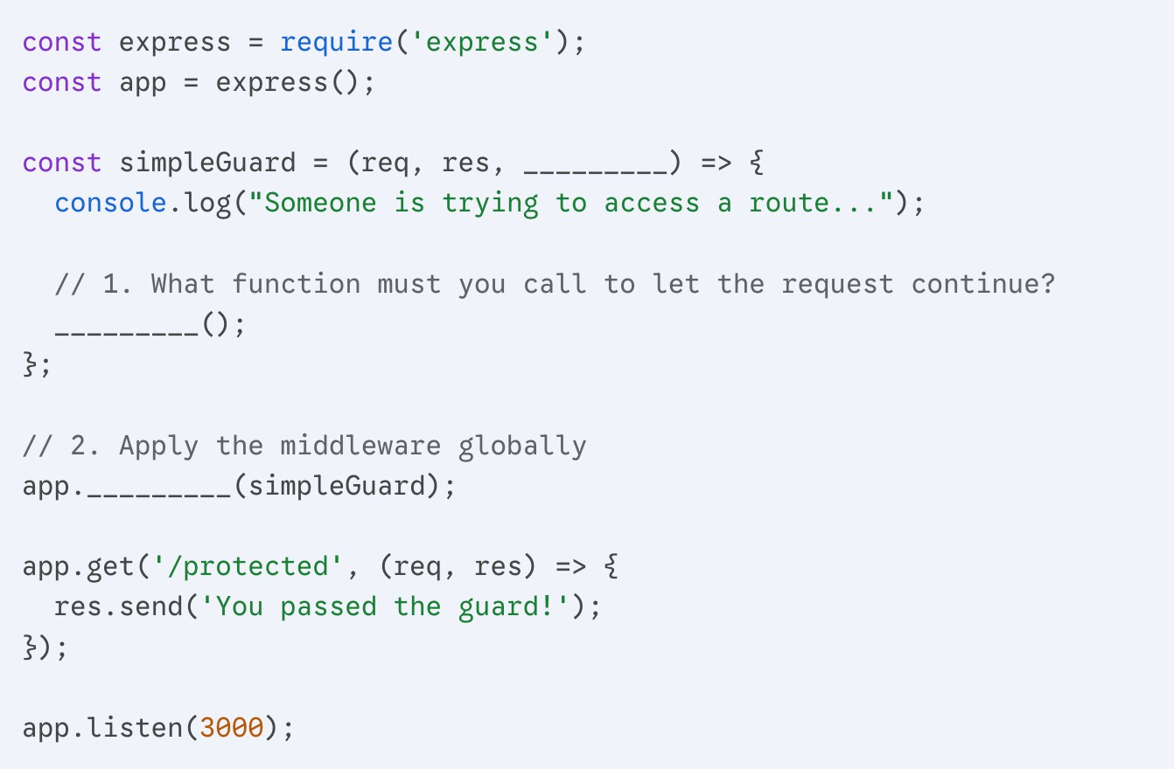

Answer =>

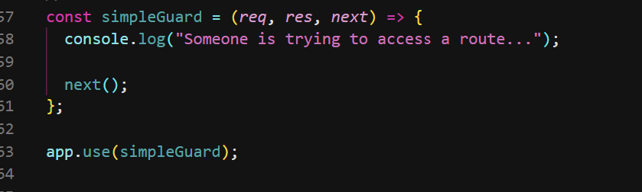
Ex06: Preparing for POST Data
Goal: Configure Express to understand incoming JSON data (Crucial for Exercise 3).
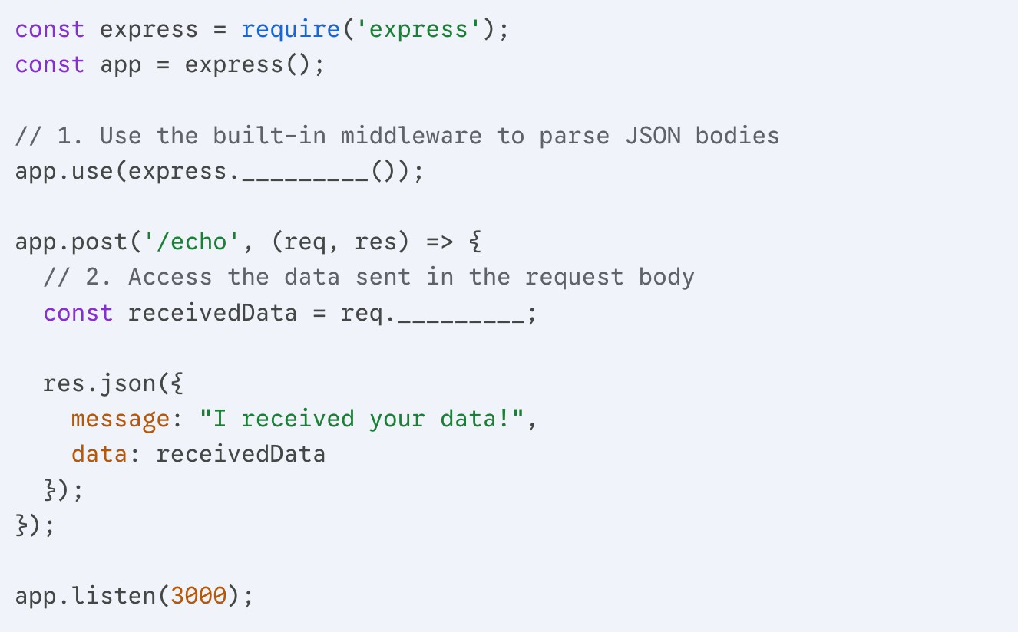
- Run your code from Server.
- In Apidog, create a New Request set to POST.
- URL: http://localhost:3000/echo.
- Go to the Body tab, select JSON, and type: {"name": "Dara"}.
- Hit Send and see if the server echoes it back!

Answer =>

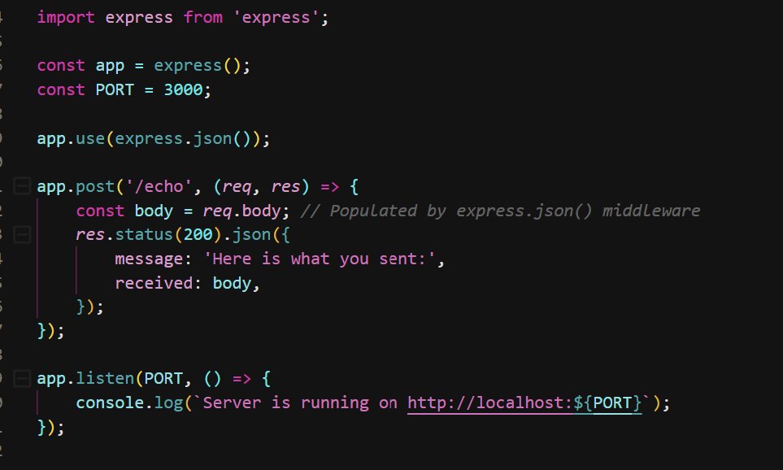

Ex07: The Logic Gate (Status Codes)
Goal: Practice sending different HTTP status codes based on user input. This is essential for the "Invalid credit ranges" task in Exercise 2.
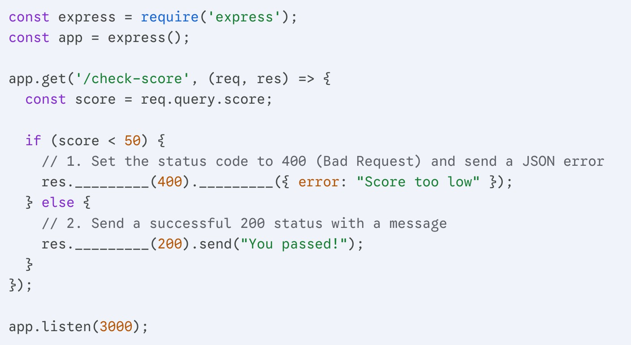

Answer = >
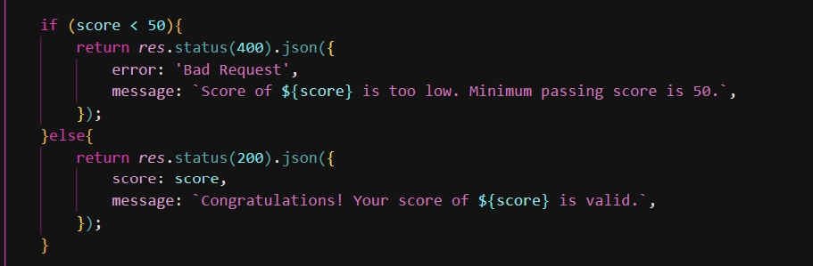

Ex08: The "Auto-File" Server (express.static)
Goal: Understand how Express simplifies serving CSS, Images, or HTML files without manual routing.
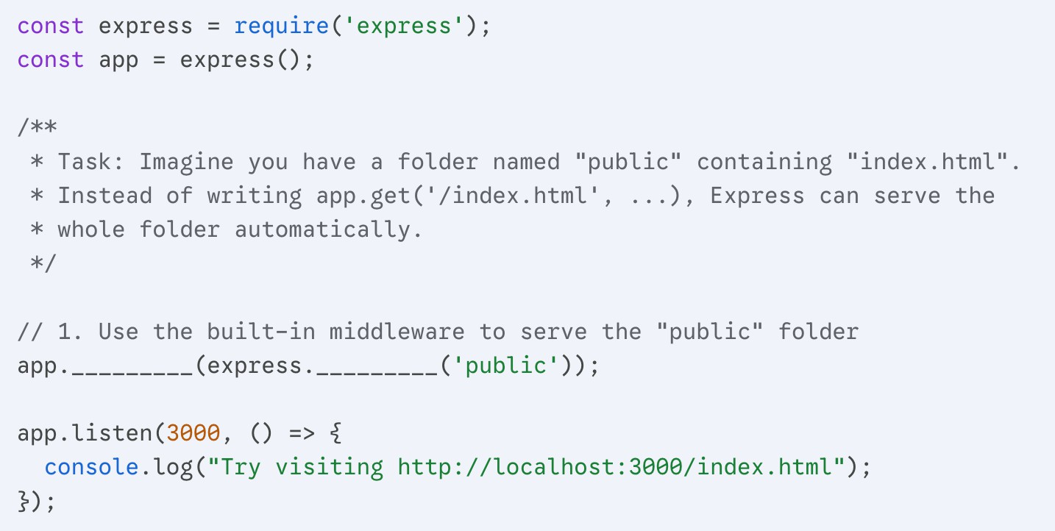

- Enter http://localhost:3000/check-score?score=40.
- After hitting Send, look at the top right of the response panel.
- You will see 400 Bad Request in red. This confirms your server is communicating the "state" of the request correctly to the client!

Answer =>

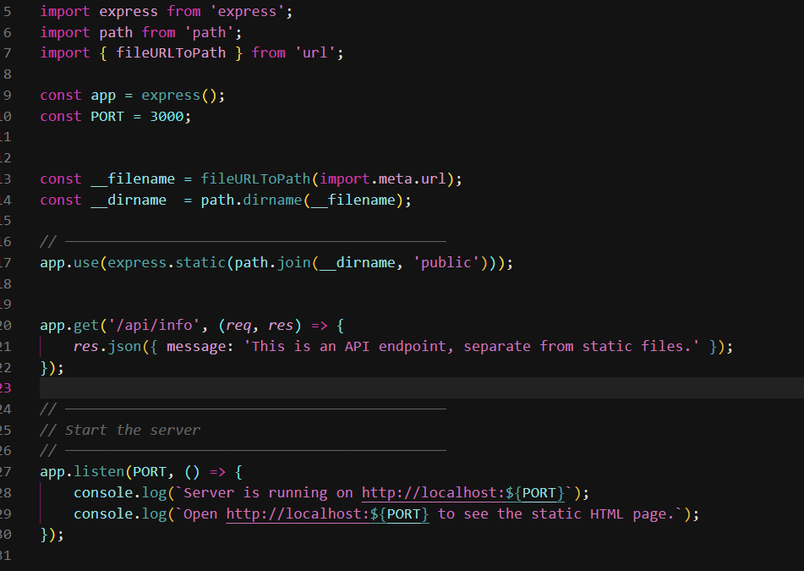
Ex09: API for Course Records
For this exercise you will start with a START CODE (EX-2)

Goals
  - Understand Route Parameters (:param)
  - Work with Query Parameters (?key=value)
  - Implement Conditional Logic for Filtering
  - Build Real-World Web API Behavior
  - Practice Defensive Programming

Context
You are building a backend API for a university's course catalog. Each course has the following fields
{
"id": "CSE101",
"title": "Introduction to Computer Science", "department": "CS",
"level": "undergraduate", "credits": 3, "instructor": "Dr. KimAng", "semester": "fall"
}

Q1 - Create a route
GET /departments/:dept/courses
EXAMPLE
/departments/CSE/courses

Q2 - Accept query parameters to filter the result:

    - level → e.g., undergraduate, graduate
    - minCredits → integer
    - maxCredits → integer
    - semester → fall, spring, etc.
    - instructor → partial match

EXAMPLE
/departments/CSE/courses?level=undergraduate&minCredits=2&semester=fall

Q3 - Return a JSON array of courses that match:
    - The :dept from the route parameter
    - The filter criteria from query parameters

Q4 – Handle Edge Cases

    - Invalid credit ranges (minCredits > maxCredits)

No matching courses
    - Missing or unsupported query parameters (ignore them silently)

EXAMPLES

REQUEST
/departments/CSE/courses?level=undergraduate&minCredits=3&instructor=KimAng
RESPONSE
{
"results": [
{
"id": "CSE101",
"title": "Introduction to Data Science", "department": "CSE",
"level": "undergraduate", "credits": 3,
"instructor": "Dr. KimAng", "semester": "fall"
}
],
"meta": {
"total": 1
}
}

Test cases

- http://localhost:3000/departments/CSE/courses
- http://localhost:3000/departments/CSE/courses?level=undergraduate
- http://localhost:3000/departments/CSE/courses?minCredits=4
- http://localhost:3000/departments/CSE/courses?instructor=smith&semester
=fall

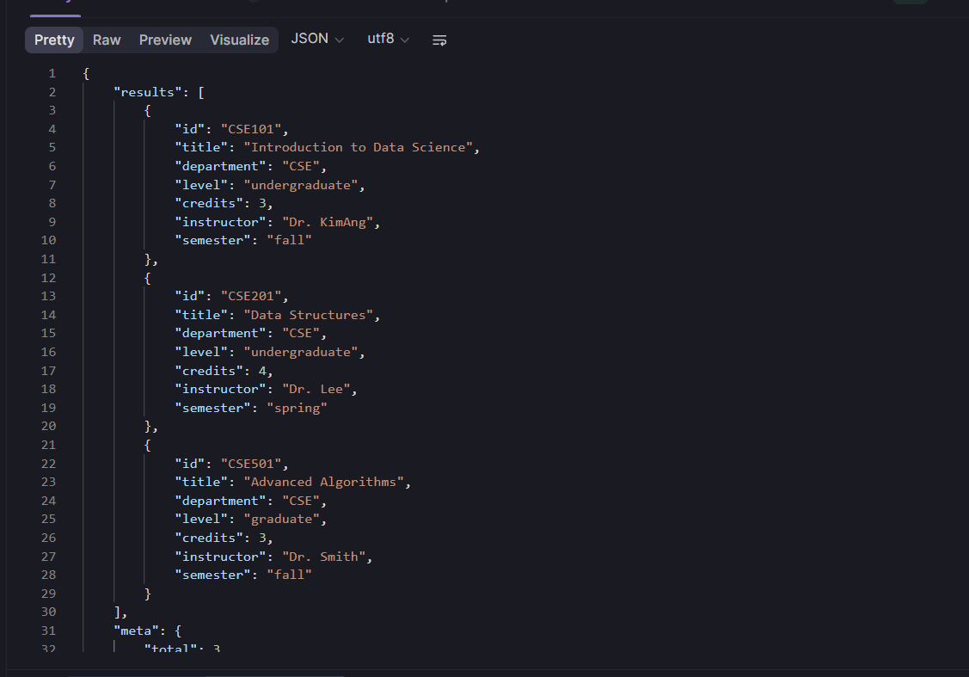

Ex10: Enhance an API with Middleware

Goal

Your goal is to modularize and secure your course filtering API using Express middleware. Middleware helps keep your code clean, reusable, and extensible.

Q1 - Create a middleware function that logs the following for every request:

- HTTP method (GET, POST, etc.)
- Request path (e.g., /departments/CSE/courses)
- Query parameters
- Timestamp in ISO format

  - Apply this middleware globally so it logs all incoming requests to the server.

Q2 - Create a route-specific middleware to validate query parameters:

- If minCredits or maxCredits are present, ensure they are valid integers.
- If minCredits > maxCredits, return 400 Bad Request with an error message.

  - Apply this middleware only to the /departments/:dept/courses route.

Q3 – (Bonus) Token-Based Authentication Middleware Simulate basic API security:
- Require a token query parameter (e.g., ?token=xyz123)
- If the token is missing or incorrect, respond with 401 Unauthorized.

  - This middleware can be pplied either globally or to specific routes.

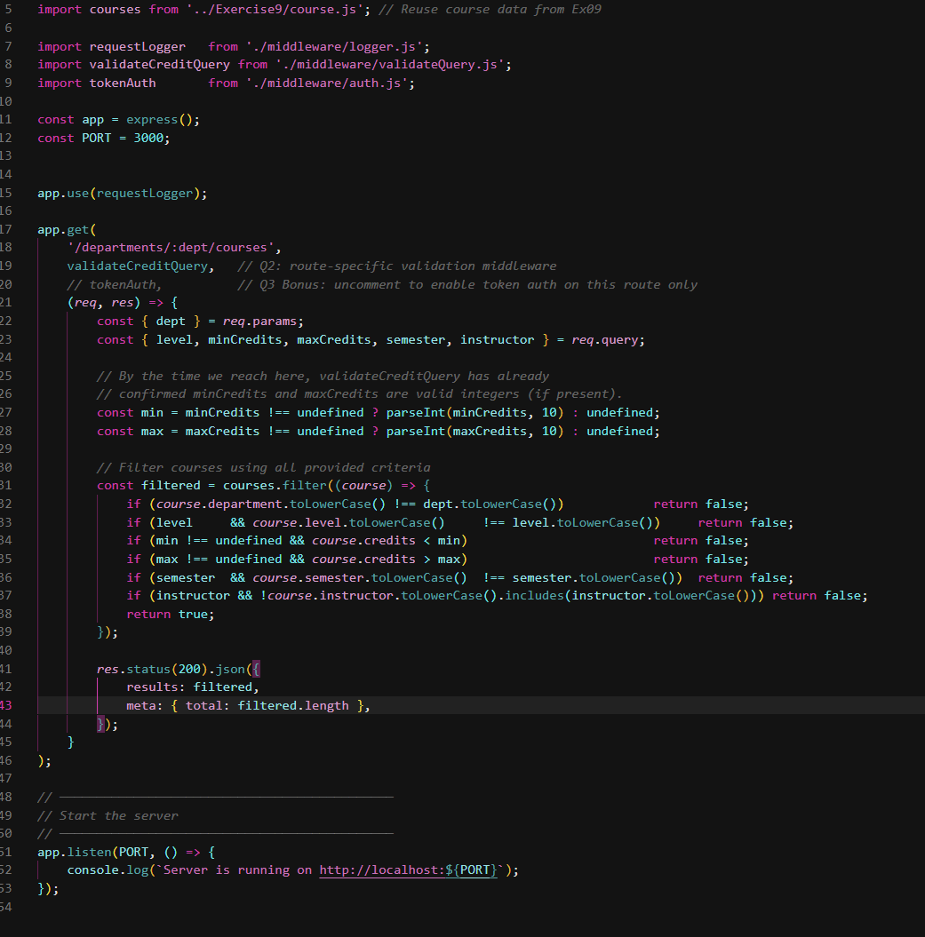
Deliverables

- logger.js – contains your logging middleware.
- validateQuery.js – contains your validation middleware.
- auth.js (optional) – contains your token authentication middleware.
- server.js – where you apply middleware and define the course filtering route.

Test cases
GET /departments/CSE/courses?minCredits=abc

→ should return 400 Bad Request
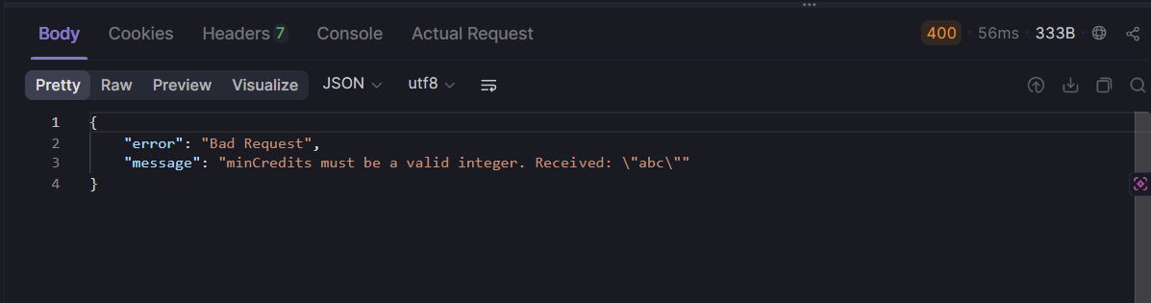

GET /departments/CSE/courses?minCredits=4&maxCredits=2

→ should return 400 Bad Request

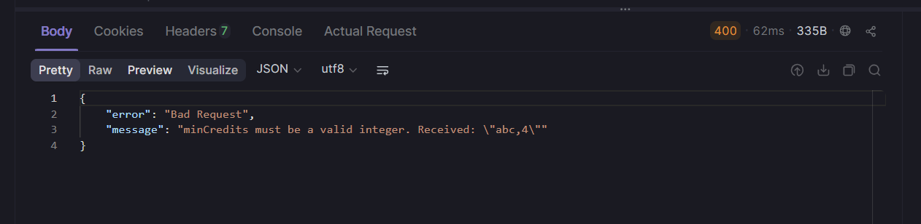
GET /departments/CSE/courses?token=xyz123

→ should succeed if token middleware is active

REFLECTIVE QUESTIONS

For this part, submit it in separate PDF files

Middleware & Architecture
- What are the advantages of using middleware in an Express application?
- Middleware promotes separation of concerns. Each middleware function has a single responsibility (logging, auth, validation), making the codebase easier to read, test, and maintain. It also enables reuse, the same logger or auth function can be applied to many routes without duplication. The request pipeline is explicit and composable: you can see exactly what runs before a route handler just by reading the app.use( ) and route calls.

- How does separating middleware into dedicated files improve the maintainability of your code?
- When each middleware lives in its own file (logger.js, validateQuery.js, auth.js), teams can work on them independently without merge conflicts. It also makes unit testing straightforward, each function can be tested in isolation by passing mock req, res, and next objects. If a behavior needs to change (e.g., switching log format), only one file needs to be updated, not every route.

- If you had to scale this API to support user roles (e.g., admin vs student), how would you modify the middleware structure?
- A role-based approach would work in two stages. First, an auth middleware validates the token and attaches the decoded user (including their role) to req.user. Second, a separate authorize(roles) factory function creates route-specific middleware that checks req.user.role against an allowed list:

const authorize = (allowedRoles) => (req, res, next) => {
if (!allowedRoles.includes(req.user.role))
return res.status(403).json({ error: "Forbidden" });
next();
};

// Admin-only route
app.delete("/courses/:id", tokenAuth, authorize(["admin"]), handler);

Query Handling & Filtering
- How would you handle cases where multiple query parameters conflict or are ambiguous (e.g., minCredits=4 and maxCredits=3)?
- This is exactly what the validateCreditQuery middleware addresses. The rule is simple: if minCredits > maxCredits, respond with a 400 Bad Request immediately, before the filter logic ever runs. This prevents the filter from returning an empty result for an impossible range without explaining why.

- What would be a good strategy to make the course filtering more user-friendly (e.g., handling typos in query parameters like “falll” or “dr. smtih”)?
=> Two complementary strategies work well here. First, fuzzy matching with a library like fuse.js allows approximate string matching so a query like ?semester=falll still matches courses with semester: "fall". Second, for controlled-vocabulary fields like level and semester, the API could return a helpful error listing the accepted values rather than just returning 0 results silently.

Security & Validation
- What are the limitations of using a query parameter for authentication (e.g., ?token=xyz123)? What alternatives would be more secure?

Limitations of ?token=xyz123 and more secure alternatives
Query-parameter tokens are visible in server logs, browser history, and any URLs shared by users, a significant security risk. More secure alternatives include:
- HTTP Authorization header: Bearer <token>, not logged by default and not cached.
- JWT (JSON Web Tokens) with expiry and signature verification.
- OAuth 2.0 / API key stored in a header (e.g., X-API-Key) for server-to-server APIs.

- Why is it important to validate and sanitize query inputs before using them in your backend logic?

- Unvalidated inputs are the root cause of many common vulnerabilities. Even without a database, an unvalidated integer field could cause NaN to propagate through arithmetic, producing incorrect results silently. With a database, unsanitized inputs enable SQL injection or NoSQL injection attacks. Validating early (in middleware, before the handler) ensures the handler always receives clean, type-safe data.

Abstraction & Reusability
- Can any of the middleware you wrote be reused in other projects? If so, how would you package and document it?
- Yes. requestLogger and validateCreditQuery are nearly project-agnostic. They could be published as an npm package with minimal changes, parameterize the valid token in auth.js via a constructor argument rather than a hard-coded constant, and the logger could accept a configurable format function. Documentation would describe the expected req.query shape and the next() contract.

- How could you design your route and middleware system to support future filters (e.g., course format, time slot)?

- A scalable approach is to define a filterSpec object that maps query parameter names to filter functions. Adding a new filter (e.g., ?format=online) only requires adding one entry to the spec — no changes to the route handler itself:
const filterSpec = {
level: (course, val) => course.level === val,
semester: (course, val) => course.semester === val,
format: (course, val) => course.format === val, // new filter
};

const filtered = courses.filter(course =>
Object.entries(filterSpec).every(([key, fn]) =>
req.query[key] ? fn(course, req.query[key]) : true
)
);

Bonus – Real-World Thinking
- How would this API behave under high traffic? What improvements would you need to make for production readiness (e.g., rate limiting, caching)?
- Under high traffic this in-memory array lookup is actually fast (O(n) on a small dataset), but the server would struggle to scale horizontally because the data lives in memory on a single process. Key production improvements include:
- Rate limiting (e.g., express-rate-limit): prevent abuse by limiting requests per IP per time window.
- Caching (e.g., node-cache or Redis): cache filtered results for common query combinations to avoid recomputing on every request.
- Database (e.g., PostgreSQL with indexed columns): replaces the in-memory array, enabling efficient querying across millions of courses.
- PM2 or containerization (Docker + Kubernetes): run multiple instances behind a load balancer for horizontal scaling.
- Input validation library (e.g., Joi or Zod): replace manual parseInt checks with a schema-based validator for robustness and reusability.

